UNDER THE SHADE OF THE BAOBAB

Outline
- Introduction

- Meeting under the Baobabs

- A youth’s vision

- Storm on the horizon

- Reflection

The sun hovered just above the horizon, its amber light stretched long and soft across the dusty plain. I stepped off the rutted minibus in the small Tanzanian village of Mto wa Mbu, shaking loose the last grains of red earth from my shoes. In the distance, ancient baobab trees stood like silent sentinels bulbous trunks carved by time, their branches reaching skyward in a sky that glowed like molten gold.
Children’s laughter drifted on the wind. A goat bleated somewhere nearby. Smoke curled upward from a wood-fired hearth, carrying the scent of burning acacia wood and freshly baked maize bread. The air was warm, but not suffocating, a gentle heat that pressed softly against my skin. This was not just a place I had traveled to; it was a world I had entered.
I had come to Tanzania for many reasons, but one central thread wound through all of them: to understand how climate change was reshaping the lives of ordinary people, and how, in turn, they were shaping their land. Here, in this remote village halfway between the plains of the Serengeti and the dense, tangled hammock of lake shoreline, I believed I might find stories of resilience, of tradition meeting innovation, of hardship meeting hope.
Under the shade of a massive baobab, I met Mama Salome, an elder whose silver hair glinted in the fading light. Her wrinkles told a story of decades, decades of drought and rain, famine and plenty, of changes she had seen in her lifetime.
She invited me to sit on a woven stool carved from sisal. As we talked, her voice was quiet but steady. She spoke of the land: how, in her youth, the rains were frequent, generous, unpredictable; how now they came later or not at all, leaving the soil cracked and parched.
“When I was young,” she said, “we had water in the rivers by November. Now, by November the riverbed is dry and the cattle wander far for grass.”
Her eyes flicked to a small mound of stones where young saplings struggled to grow. A reforestation project run by a local cooperative had brought seedlings of native trees including young baobabs, to the village. These trees, she believed, would help the community, not just for shade and beauty, but for water. Their roots could help rebuild the soil, anchor it, make it more receptive to the hard-earned drops of rain.
Later that afternoon, I followed a narrow footpath down to a small workshop where I met Juma, a 22-year-old engineer and entrepreneur. He was tinkering with a small contraption: a plastic shredder. Around him lay discarded water bottles, sachets and other plastic rubbish collected from nearby communities.
Juma explained his ambition: to melt and compress the plastic into molds that could serve as cooking fuel or building bricks. His eyes brightened when he spoke of his dream. The vision was not only practical, it was deeply personal.
“I grew up here, in this place,” he told me, “and I watched our waste pile up. We lacked clean energy. Why not turn what we discard into something useful?”
He leaned forward, hands resting on the metal frame. “When we melt the plastic, it's more than just fuel,” he said almost reverently. “It becomes our power.”
As I watched him work, the sun dipped lower, casting long shadows across the dusty yard. I thought about how this simple innovation could connect so many threads: waste, energy, climate change and community dignity.
That evening, the sky changed. Clouds rolled in from the west, thick and bruised. The wind picked up, stirring the baobab leaves until they whispered. In a short while, thunder rumbled far off and a sudden downpour began.
I scrambled for cover under a lean-to, the wooden frame barely shielding me from the heat of the rain and the splash of mud. The storm was fierce but brief, leaving the ground damp and cooling the air. The smell of wet earth rose that special smell, petrichor, that feels like both cleansing and promise.
Salome came out from her hut, lifting her skirt to step outside. She closed her eyes and let the rain soak her face. “It’s good,” she said softly. “It’s good.”
Under that sky, I realized just how precarious and precious life here was, how every drop of rain, every seedling, every innovation mattered.
As I lay that night on a simple mat under a mosquito net, I thought about the stories I had just begun to uncover. There was power in memory (Salome), in youth-led innovation (Juma) and in nature itself (the baobabs, the rain). These were not separate stories, they were part of a single tapestry, woven together by time and necessity.
I felt the weight of responsibility: to tell this story honestly, to honor the people I had met and to illuminate the delicate balance they held with their land. This was not just travel writing. It was a journey of understanding, a narrative of climate resilience and I hoped a message to the world: sometimes, the most transformative journeys are not about where we go, but what we bring back.

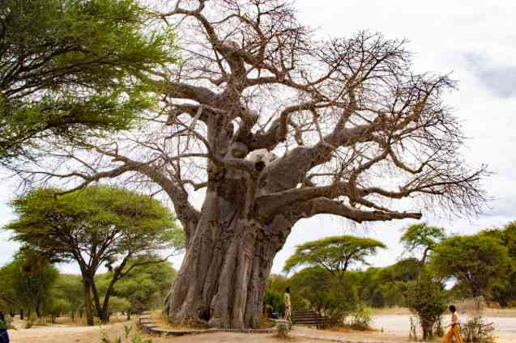
The baobab tree standing

